# **Use Case Draft Documentation**

|  |  |  |  |
| --- | --- | --- | --- |
| **Name** | **Date** | **Version** | **Remark** |
| Mak Jun Kit | 03/07/2024 | 1.0 | - Created the first draft for the Use Case design for the basic SQL. |
| Mak Jun Kit | 03/07/2024 | 1.1 | - Changed the diagram and added some more functions for both **Artist** and **Viewer**. |

## **Use Case Diagram**

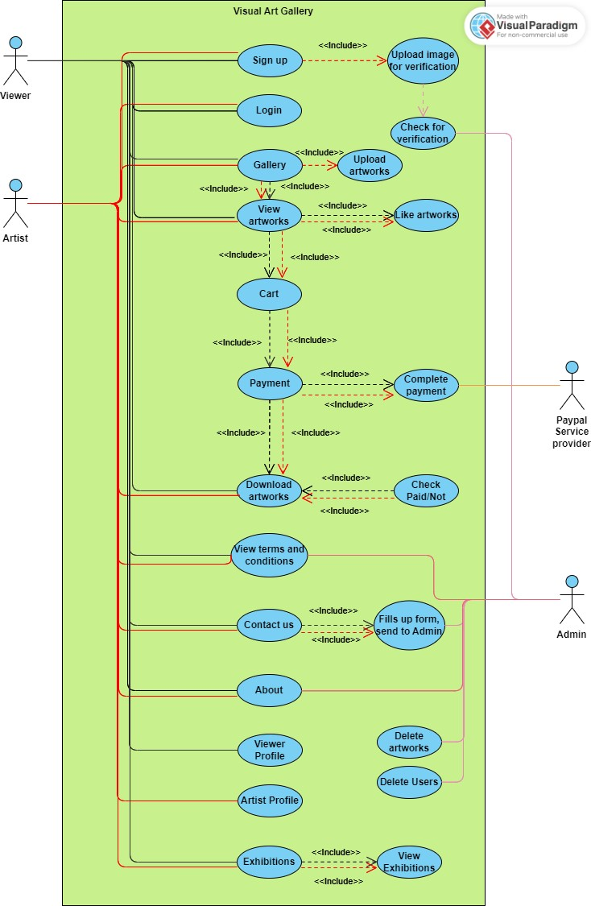

## **Viewer**

* What is the ***Viewer*** and what functions it can do?
* The ***Viewer*** has the least permissions among all.
* The ***Viewer*** has these functions:
  + Sign Up.
  + Login.
  + Gallery – View Artworks – Like Artworks – Add to Cart – Payment – Complete Payment – Check Paid/Not – Download Artworks.
  + View Terms and Conditions.
  + Contact Us – Fills up form and send to Admin.
  + About.
  + Viewer Profile (Set up/edit own profile).
  + Exhibitions – View Exhibitions.

## **Artist**

* What is the ***Artist*** and what functions it can do?
* The ***Artist*** has moderate permissions among all.
* The ***Artist*** has these functions:
  + Sign Up – Upload image for verification – Wait for verification from Admin.
  + Login.
  + Gallery – View Artworks – Like Artworks – Upload Artworks – Add to Cart – Payment – Complete Payment – Check Paid/Not – Download Artworks.
  + View Terms and Conditions.
  + Contact Us – Fills up form and send to Admin.
  + About.
  + Artist Profile (Set up/edit own profile).
  + Exhibitions – View Exhibitions.

## **Admin**

* What is the ***Admin*** and what functions it can do?
* The ***Admin*** has the highest permissions among all.
* The ***Admin*** has these functions:
  + Permissions to add/edit/delete all pages.
  + Permissions to edit/delete all artworks.
  + Permissions to edit/delete Viewer/Artist.
  + Verifies the Artist’s image and Artworks.
  + Controls the Terms and Conditions page.
  + Controls the Contact Us page – including the forms and replying.
  + Controls the About page.

## **PayPal Service Provider**

* What is the ***PayPal*** ***Service*** ***Provider*** and what functions it can do?
* The ***PayPal*** ***Service*** ***Provider*** has minimal permissions among all.
* The ***PayPal*** ***Service*** ***Provider*** has these functions:
  + Manage the Checkout/Payment process page.